* Sequential diagram:
* Selling subsystem: -

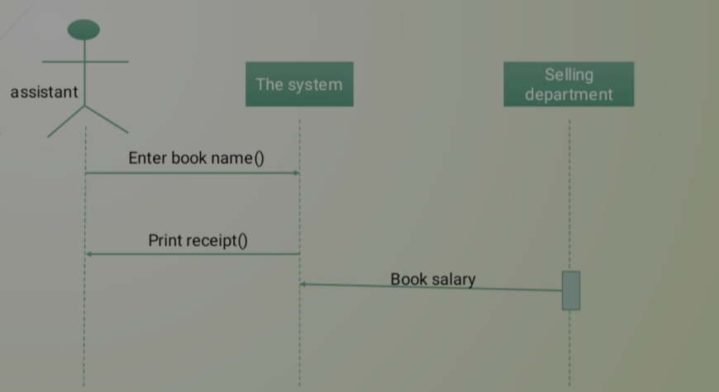

* Storage subsystem: -

